Hydrolysis of Salts and Reactions of Acids and Bases

Example 1
Determining the Acidic or Basic Nature of Salts
Determine whether aqueous solutions of the following salts are acidic, basic, or neutral:
(a) KBr
(b) NaHCO₃
(c) NH₄Cl
(d) Na₂HPO₄
(e) NH₄F
Solution
Consider each of the ions separately in terms of its effect on the pH of the solution, as shown here:
(a) The K⁺ cation and the Br⁻ anion are both spectators, since they are the cation of a strong base (KOH) and the anion of a strong acid (HBr), respectively. The solution is neutral.

(b) The Na⁺ cation is a spectator, and will not affect the pH of the solution; while the anion is amphiprotic, it could either behave as an acid or a base. The K_{a} of is 4.7 × 10⁻¹¹, so the K_{b} of its conjugate base is .
Since K_{b} >> K_{a}, the solution is basic.

(c) The ion is acidic and the Cl⁻ ion is a spectator. The solution will be acidic.
(d) The Na⁺ ion is a spectator, while the ion is amphiprotic, with a K_{a} of 4.2 × 10⁻¹³ so that the K_{b} of its conjugate base is . Because K_{b} >> K_{a}, the solution is basic.

(e) The ion is listed as being acidic, and the F⁻ ion is listed as a base, so we must directly compare the K_{a} and the K_{b} of the two ions. K_{a} of is 5.6 × 10⁻¹⁰, which seems very small, yet the K_{b} of F⁻ is 1.4 × 10⁻¹¹, so the solution is acidic, since K_{a} > K_{b}.

Try yourself
Determine whether aqueous solutions of the following salts are acidic, basic, or neutral:
(a) K₂CO₃
(b) CaCl₂
(c) KH₂PO₄
(d) (NH₄)₂CO₃
(e) AlBr₃
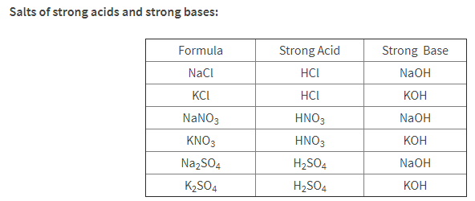
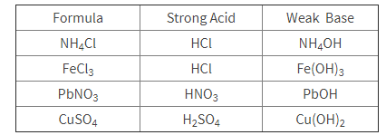

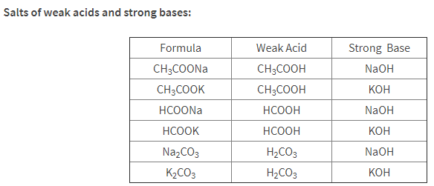
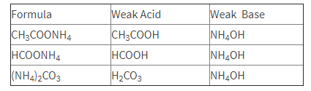

Describe each as an acid, base, neutral salt, acidic salt, or basic salt. For each salt write a parent acid-base formation equation, dissociation equation, and hydrolysis equation (only for acidic and basic salts). For acids and bases write an equation to show how each reacts with water.

1. NH₃

2. KCl

3. HNO₃

4. NaHCO₃

5. RbOH

6. AlCl₃

7. H₂C₂O₄

8. NaC₆H₅O

9. Co(NO₃)₃

10. Na₂CO₃

Hydrolysis of Salts and Reactions of Acids and Bases

Describe each as an acid, base, neutral salt, acidic salt, or basic salt. For each salt write a dissociation equation and hydrolysis equation (only for acidic and basic salts). For acids and bases write an equation to show how each reacts with water.

1. NH₃

2. NaCl

3. HCl

4. NaCN

5. NaOH

6. FeCl₃

7. HF

8. LiHCO₃

9. Fe(NO₃)₃

10. MgCO₃

11. H₂S

12. HF

13. CaI₂

14. Mg(OH)₂

15. Ba(OH)₂

16. Describe why Tums (CaCO₃) neutralizes stomach acid.

17. Describe why Mg(OH)₂ is used in Milk of Magnesia as an antacid instead of NaOH.

ANSWERS
WS # 1 Hydrolysis of Salts and Reactions of Acids and Bases
Describe each as an acid, base, neutral salt, acidic salt, or basic salt. For each salt write a parent acid-base formation equation, dissociation equation, and hydrolysis equation (only for acidic and basic salts). For acids and bases write an equation to show how each reacts with water.
1. NH₃ weak base

NH₃ + H₂O ⇄ NH₄⁺ + OH⁻

2. KCl neutral salt

HCl + KOH → KCl + H₂O

KCl → K⁺ + Cl⁻

3. HNO₃ strong acid

HNO₃ + H₂O → H₃O⁺ + NO₃⁻

4. NaHCO₃ basic salt

H₂CO₃ + NaOH → NaHCO₃ + H₂O

NaHCO → Na⁺ + HCO₃⁻

HCO₃⁻ + H₂O ⇄ H₂CO₃ + OH⁻

5. RbOH strong base

RbOH → Rb⁺ + OH⁻

6. AlCl₃ acid salt

3HCl + Al(OH)₃ → AlCl₃ + 3H₂O

AlCl₃ → Al⁺³ + 3Cl⁻

Al(H₂O)₆³⁺ ⇄ Al(H₂O)₅(OH)²⁺ + H⁺

7. H₂C₂O₄ weak acid

H₂C₂O₄ + H₂O ⇄ H₃O⁺ + HC₂O₄⁻

8. NaC₆H₅O basic salt

C₆H₅OH + NaOH → NaC₆H₅O + H₂O

NaC₆H₅O → Na⁺ + C₆H₅O⁻

C₆H₅O⁻ + H₂O ⇄ C₆H₅OH + OH⁻

9. Co(NO₃)₃ acid salt

3HNO₃ + Co(OH)₃ → Co(NO₃)₃ + 3H₂O

Co(NO₃)₃ → Co⁺³ + 3NO₃⁻

Co(H₂O)₆³⁺ ⇄ Co(H₂O)₅(OH)²⁺ + H⁺

10. Na₂CO₃ basic salt

H₂CO₃ + 2NaOH → Na₂CO₃ + 2H₂O

Na₂CO₃ → 2Na⁺ + CO₃⁻²

CO₃⁻² + H₂O ⇄ HCO₃⁻ + OH⁻

WS # 2 Hydrolysis of Salts and Reactions of Acids and Bases

Describe each as an acid, base, neutral salt, acidic salt, or basic salt. For each salt write a parent acid-base formation equation, dissociation equation, and hydrolysis equation (only for acidic and basic salts). For acids and bases write an equation to show how each reacts with water.
1. NH₃ weak base

NH₃ + H₂O ⇄ NH₄⁺ + OH⁻

2. NaCl neutral salt

NaCl → Na⁺ + Cl⁻

3. HCl strong acid

HCl + H₂O → H₃O⁺ + Cl⁻

4. NaCN basic salt

NaCN → Na⁺ + CN⁻
CN⁻ + H₂O ⇄ HCN + OH⁻

5. NaOH strong base

NaOH → Na⁺ + OH⁻

6. FeCl₃ acid salt

FeCl₃ → Fe⁺³ + 3Cl⁻

Fe(H₂O)₆³⁺ ⇄ Fe(H₂O)₅(OH)²⁺ + H⁺

7. HF weak acid

HF + H₂O ⇄ H₃O⁺ + F⁻

8. LiHCO₃ basic salt

LiHCO₃ → Li⁺ + HCO₃⁻
HCO₃⁻ + H₂O ⇄ H₂CO₃ + OH⁻

9. Fe(NO₃)₃ acid salt

Fe(NO₃)₃ → Fe⁺³ + 3NO₃⁻

Fe(H₂O)₆³⁺ ⇄ Fe(H₂O)₅(OH)²⁺ + H⁺

10. MgCO₃ basic salt

MgCO₃ → Mg⁺² + CO₃⁻²
CO₃⁻² + H₂O ⇄ HCO₃⁻ + OH⁻

11. H₂S weak acid

H₂S + H₂O ⇄ H₃O⁺ + HS⁻

12. HF weak acid

HF + H₂O ⇄ H₃O⁺ + F⁻

13. CaI₂ neutral salt

CaI₂ → Ca⁺² + 2I⁻

14. Mg(OH)₂ weak base

Mg(OH)₂ ⇄ Mg⁺² + 2OH⁻

15. Ba(OH)₂ strong base

Ba(OH)₂ → Ba⁺² + 2OH⁻

16. Describe why Tums (CaCO₃) neutralizes stomach acid. It is a weak base and will neutralize acid.
basic salt
CaCO₃ → Ca⁺² + CO₃⁻²
CO₃⁻² + H₂O ⇄ HCO₃⁻ + OH⁻

17. Describe why Mg(OH)₂ is used in Milk of Magnesia as an antacid instead of NaOH.
Mg(OH)₂ is weak base and releases OH⁻ slowly, whereas NaOH is a strong base which releases OH⁻ in high concentrations which is corrosive.
Mg(OH)₂ ⇄ Mg⁺² + 2OH⁻
NaOH → Na⁺ + OH⁻

